CONTENT

Ⅰ Product sketch diagram 37

Ⅱ Summary 38

Ⅲ Operation instruction 43

1. Introduction of the boot, measurement page and mode 43

2. A brief introduction to the main menu page 47

3. Settings 49

4. MODE CHOOSE 60

5. BASE MODE PAGE 61

6. SAMPLE MODE PAGE 63

7. STATISTIC MODE PAGE 67

8 CONTINUOUS MODE PAGE 71

9. Version 72

IV Common problem processing 73

Ⅰ Product sketch diagram

Test（Test key）

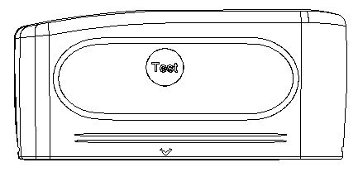

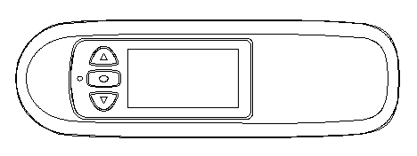

Screen

A Facade

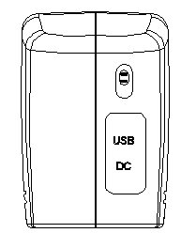

Enter

Up

Power

USB interface

DC interface

Down

C Back side

B Top side

Lampstand

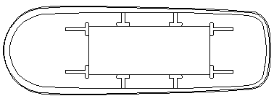

Calibration plate

D Bottom calibration

# Ⅱ Summary

**The use of multi angle gloss meter**

(1).The "gloss meter" refers to a mirror or a specula gloss meter；

(2).The standard plate refers to the standard device used in the instrument calibration for the instrument calibration.；

(3).The instrument should avoid strong electromagnetic interference, is not used in the humidity is greater than 85%, condensation in the environment.

**Warranty and technical support**

If your instrument is damaged in the warranty period, please contact the local sales department or contact us for free maintenance.

At any time we can provide spare parts to distributors or customers, such as the standard plate, etc..

In order to avoid affect instrument accuracy and increase the maintenance difficulties, please do not disassemble the instrument privately; The user should be responsible for damage resulted in disassemble or incorrect use to the instrument.

**Standard for gloss meter**

(1)、ISO2813，ISO7668

(2)、ASTM D523，ASTM D2457

(3)、GB/T 9754，GB/T 13891，GB/T 7706，GB/T 8807

All performance indexes meet the primary working machine requirements of metrological verification procedures of national standard “JJG696-2002 mirror gloss meter and gloss board”. Apply on paint, ink, stoving varnish, coating, wood products; Marble, granite, vitrified polished tile,

Pottery brick and procelain; Plastic, paper; Other nonmetallic material.

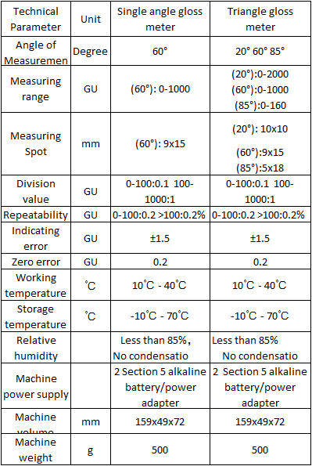

**Gloss meter function description**

(1).One key to complete the measurement：

A operation can simultaneously complete triangle gloss meter measurement；Measuring light incident angle is to meet the requirements of ISO 2813 three measuring light incident angle. The angle of three angles of the mirror is respectively20°、60°、85°；

(2).Optional angle mode: combination of measurement angle or angle can be selected by user;

(3).Can manually enter the sample gloss data；

(4).Humanized design, good human-machine interactive interface；

(5).Triangle degree can store 50000（Single angle is 10000）data records, storage organization:100 types，each type can be stored

500（Single angle is 100 data record；

(6).Data view function；

(7).This machine has the function of automatic power off function, low battery reminder function, and notification of full storage space；

(8).USB communication interface with PC；

(9).PC gloss meter software can expand more functions.

**Annex description**

(1).Power adapter: Standard+5V,2A external power supply；

(2).Standard plate: provide calibration standards for the instrument；

(3).Data cable: connection between the instrument and PC.

# Ⅲ Operation instruction

## 1. Introduction of the boot, measurement page and mode

**CALIBRATION**

20° 60° 85°

←

Figure 1a

Multi-angle

**CALIBRATION**

60°

←

Figure 1b

Single angle

Put the gloss meter on the base, then dial the switch to "O" to open the instrument, the instrument will be automatically calibrated, as shown in Figure 1.

**CALIBRATION**

20° 60° 85°

PASS PASS PASS

←

Figure 2a

Multi-angle

←

图2

**CALIBRATION**

60

PASS

←

Figure 2b

Single angle

If the instrument is automatically calibrated when the page appears as shown in Figure 2, the calibration is successful.

Figure 1a, 2a is multi angle gloss meter boot calibration process, Figure 1b, 2b is single angle gloss meter boot calibration process. **Follow the instructions**, as multi angle for example to describe, single angle settings are same with multi angle, only data show 60 degrees on the display.

After the calibration, the instrument automatically jumps to the measurement page, as shown in Figure 3. In Figure 3, there are two kinds of operation：

(1).Press "Test" key to measure；

(2).Press the menu button to enter the main menu page, as shown in Figure 4.

ANGLE VALUE

20° 90.7

60° 94.8

85° 93.1

**Basic-M** GU

←

Figure 3

**Illustrate：**

1.The measurement page is the measurement mode before the shutdown. If the gloss meter enter into the recovery factory settings, the instrument starts measurement, and automatically enter the basic mode page, as shown in Figure 3；

2.Figure 3 shows, "GU" on behalf of the current measurement value for gloss units, if the location is "REF", said current value for reflectance units (unit setting please refer to 3.5 unit option).

MENU

RECORD

SAMPLE/DIF

SETTINGS

MODE CHOOSE

←

Figure 4

Appear as shown in Figure 5, said the boot calibration is failure, you can enter the main menu for manual calibration (reference 3.3), when manual calibration, please ensure that：

(1).The base calibration plate is clean.；

(2).The instrument is placed correctly on the calibrate plate.

**CALIBRATION**

20° 60° 85°

FAIL FAIL FAILE

←

Figure 5

## 2. A brief introduction to the main menu page

(1).When set main menu, press a measure button and will return to the previous menu；

(2).After the cursor moved to the sampling record, press the confirmation key and enter the sampling record page, the user can view a sample under a sample of statistical measurement records；

(3).The cursor moves to the type and tolerance page, then enter the type and tolerance page, the user can choose the type and set the tolerance of the type；

(4).After the cursor move to the setting, press the confirmation button and enter the settings page, where the user can set the parameters of the system；

(5).The cursor to mode selection and press confirm key, enter mode selection page, the user can choose one of the four measurement modes in basic mode, sampling mode, statistical modeland continuous mode in the page；

(6).After the cursor moves to the standard input, press the confirmation button and enter the standard sample input page, where the user can enter the standard sample values；

(7).The cursor moves to the language option, press the confirmation button and enter the language selection page, where the user can choose to Chinese or English；

(8).The cursor moves to the system version number, press the confirmation button and see the version number of the instrument.

## 3. Settings

Under the main menu page, through pressing up and down key to select settings, press confirm key, go to settings page, in the settings page, user can carry out the operations: set the date and time, sampling angle setup, calibration, pattern , unit selection, backlight time setting, automatic shutdown time setting, empty test data, restore factory settings. As shown in Figure 6.

Through up and down button, press the confirmation button to enter the page, press the measure button to return to the upper level of the page.

←

Figure 6

SETTINGS

DATE/TIME

ANGLE CHOOSE

CALIBRATION

MODE SETTINGS

The following is specific settings under the setting.

**3.1 DATE&TIME SET**

2015-01-05

04:08:23

DATE&TIME SET

←

Figure 7

In the date and time settings page, as shown in Figure 7. Press "Enter" button to move the cursor "111", by pressing the "Up" and "Down" to adjust values. When all numerical adjustments are finished, press the "Test" button to enter the save page, as shown in Figure 8, whether the change is saved or not.

←

Figure 8

SAVE THE CHANGES?

<YES> <NO>

**3.2 ANGLE CHOOSE**

←

Figure 9

ANGLE CHOOSE

20

60

85

20 60

In angle select page, 6 combination angle is available, as shown in Figure 9. Choose one of them as required, select the sample by pressing "up" and "down" button and choose the angle of the sample, which will be followed by the following. Press the "Test" button to enter the save page as shown in figure, and whether the change is saved or not, as shown in Figure 8.

**3.3 CALIBRATION**

SETTINGS

DATE/TIME

ANGLE CHOOSE

CALIBRATION

MODE SETTINGS

CALIBRATION PAGE

CALIBRATION

CAL. MODIFY

CAL. MODIFY

20° 60° 85°

92.1 95.5 99.8

←

Figure 10

SAVE THE CHANGES?

<YES> <NO>

In calibration page, as shown in figure 10, pressing "up"“down”"key to select the" CALIBRATION ", enter confirm for calibration, please make sure the "standard plate" value quickly and accurate. If the "standard plate" value is inconsistent with the " CALIBRATION " of the instrument, select “CAL. MODIFY”, as shown in figure 10, please refer to the way of modify number and save data in "3.1 DATA&TIME SET” setting.

**3.4 MODE SETTINGS**

As shown in figure 11, the "MODE CONFIG" system operation flow chart. “BASE" and "SAMPLE" no mode setting, when choosing one of them, it will display as shown in figure 12 pages.

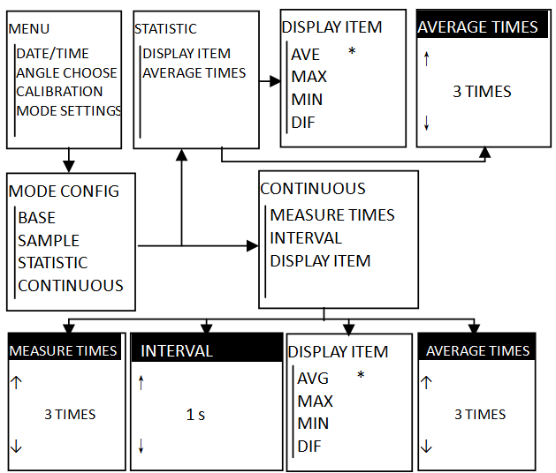

Figure 11

BASE MODE SET

NO RELATIVE SETTING

←

Figure 12

In the "STATISTIC", find "DISPLAY ITEM" , there are five choices : AVG(average), MAX(maximum), MIN(minimum), DIF(difference), STD(Sample standard) ,choose one select it and save ,then exit.

In the "STATISTIC", find "AVERAGE ITEM" , press "up" and "down" button to modify the average data of measurements after the modification is completed, press the "Test" button to enter to save ,find the "YES" and "NO" to choose whether to save the changes.

In the "CONTINUOUS”, find number of “MEASURE TIMES" , press "up" and "down" button to modify the sampling frequency, after editing, press the "Test" button to save the page, find the "YES" and "NO" to choose whether to save the changes.

↑

5 s

↓

INTERVAL

←

Figure 13

In "CONTINUOUS", find "INTERVALs", shown in Figure 13, press "up" and "down" button to modify the time interval, after editing, press the "Test" button to save the page, find the "Yes" and "No" to choose whether to save the changes. Also in the "continuous mode setting", find "DISPLAY ITEM", there are five choices: AVG(average), MAX(maximum), MIN(minimum), DIF(difference), STD(Sample standard), choose one select it and save ,then exit.

**3.5 UNIT CHOOSE**

←

Figure 14

UNIT CHOOSE

GU

REF

In the "UNIT CHOOSE", shown in Figure 14, press "up" and "down" button to select one of the unit, press the "Enter" button to confirm, then press the "Test" button, find the "Yes" and "No" to choose whether to save the changes.

**3.6 BACKLIGHT**

BACKLIGHT

↑

20 s

↓

←

Figure 15

In the " BACK LIGHT ", shown in Figure 15, press "up" and "down" button to select screen time, adjusting range from 5-60 seconds. Press the "Enter" button to confirm, then press the "Test" button, find the "Yes" and "No" to choose whether to save the changes.

No operation within the specified time, the screen will be automatically extinguished.

**3.7 AUTO POWER OFF**

↑

10 MINUTE

↓

AUTO POWER OFF

←

Figure 16

In the "AUTO POWER OFF", shown in Figure 16, press "up" and "down" buttons to adjust the backlight time, adjustable range from 1-60 minutes. Press the "Test" button to save, find the "YES "and "NO" to choose whether to save the changes. No operation within the specified time, it will automatically shut down.

**3.8 CLEAR ALL DATA**

CLEAR ALL DATA?

<YES> <ON>

←

Figure 17

In the "CLEAR ALL DATA", shown in Figure 17, find the "YES" and "NO" to choose whether empty data.

**3.9 FACTORY RESET**

FACTORY RESET?

<YES> <NO>

←

Figure 18

In the "FACTORY RESET", shown in Figure 18, find the "YES" and "NO" to choose whether to restore factory settings.

## 4. MODE CHOOSE

←

Figure 19

MODE CHOOSE

BASIC MODE

SAMPLE MODE

STATISTIC MODE

CONTINUOUS MODE

In the "Mode Selection", there are four kinds of measurement modes :"BASE MODE", "SAMPLE MODE", "STATISTIC MODE" and "CONTINUOUS MODE". The following is the function of each mode.

“BASE MODE": The most simple and practical measurement mode, without saving and statistical functions;

"SAMPLE MODE": Adopt sample standard measurement mode. Standard data and tolerances must be required before "Statistics Mode" and "Continuous mode"

"STATISTIC MODE": It has statistical functions and save the data. Standard data and tolerance required before this mode. It show the measured data, the maximum, minimum, difference , Sample standard etc.

"CONTINUOUS MODE": this mode cannot save data. Standard data and tolerance required before this mode. You can set the number of measurements, automatically repeat the measurement. You can also set the time interval measured in seconds (s). Machine default time interval is 5s, shown in Figure 13.

## 5. BASE MODE PAGE

In the "Main Menu", press "up" and "down" button to select "mode selection", press "OK" button to enter the "Mode Selection" page; press "up" and "down" button to select the basic mode, press "OK "button to select the" basic

MENU

RECORD

SAMPLE/DIF

SETTINGS

MODE CHOOSE

Test Key

BASE-M GU

ANGLE VALUE

20°

60°

85°

Enter

Test Key

BASE-M GU

ANGLE VALUE

20° 90.7

60° 94.8

85° 93.1

Figure 20

Mode ", press the" Test "button to save the page, find the" Yes "and" No "to choose whether to save the changes. Back to the "Main Menu", then press "Test" button, you can enter basic mode test page.

Basic mode is commonly used measuring mode, this measurement mode cannot setting or save measurement data, the specific operation shown in Figure 20.

## 6. SAMPLE MODE PAGE

**6.1 Operation process**

In the "MENU", press "up" and "down" button to select "MODE CHOOSE", press "Enter" button to enter the "MODE CHOOSE" page; press "up" and "down" button to select the sampling mode, press "Enter" button to select the "SAMPLE MODE", press the "Test" button to save the page, find the "Yes" and "No" to choose whether to save the changes. Back to the "MENU", then press "Test" button, you can enter sampling mode test page, shown in Figure 20

In the "SAMPLE MODE" page, press the "Test" button to get the standard sample date, "T001" is automatically incremented by one when you testing again。

←

Figure 21

ANGLE VALUE

20 90.7

60° 94.8

85° 93.1

SAM-M T001 GU

**6.2 View sample record**

TYP

T001 2015-03-05

0084 16:36:09

ANGLE VALUE(Gu)

20° 90.7

60° 94.8

85° 93.1

←

Figure 22

In the "MENU", press "up" and "down" button to select "RECORD", press "Enter" button to enter the sample record page, shown in Figure 22。

**Explanation：**

“T001”：Standard serial Number；

“0084”：There are 84 groups of test data in the standard "T001";

“2015-03-05 16:36:09”：The date and time;

VIEW SAMPLE RCORD

DELETE THIS TYPE

CLEAR ALL RECORD

←

Figure 23

SAM

T001 2015-03-05

S001 16:36:09

ANGLE VALUE(Gu)

20° 90.7

60° 94.8

85° 93.1

←

Figure 24

In the "RECORD"( Figure 22), press "Enter" button to enter the sample record page, shown in Figure 23。

**Explanation：**

“View samples in the current standards”:press "OK" button to enter the page，shown in Figure 24;

“Remove standards data”: press "OK" button to remove standards data (Included84 groups of test data)

“Remove all data”: Remove all type and sample data.

## 7. STATISTIC MODE PAGE

**7.1 Standard data and tolerance setting**

MENU

RECORD

SAMPLE/DIF

SETTINGS

MODE CHOOSE

←

Figure 25

Choose “SAMPLE/DIF” and press “Enter.”

Press ”Enter”

TYPE CHOOSE

TYPE NAME：T001

TOL.VALUE ：2.0

TOLERANCE SETTING

SET AS TYPE

Chose "TOLERANCE SETTING” press “OK”

Chose "SET AS TYPE” press “OK”

TOL. SETTINGS

TYPE NAME：T001

TOL.VALUE ：2.0

SUCCESSFUL!

In the "TYPE CHOOSE", press "up" and "down" button to select data ,find the "Yes" and "No" to choose whether to save the changes. Press "up" and "down" button to enter tolerance setting, shown in Figure 25.

In the tolerance setting, press "up" and "down" button to enter tolerance, press “Test” button, find the "Yes" and "No" to choose whether to save the changes. ”Test” button to back to "MENU"

Standard data and tolerance must be required first, shown in Figure 25.

**Explanation：**

“TYPE CHOOSE“: will be the data of “Statistics mode“and”Continuous mode”

“Tolerance setting”: enter tolerance.

In choosing the prototype and setting up the tolerance, it can firstly set tolerance of prototype, and then select the required type; It can also select sample first, then set the tolerance of the same sample.

**7.2 STATISTICS MODE Operation process**

ANGLE VAL AVG RST

20° 90.3 90.9 pass

60° 95.8 94.6 fail

85° 99.6 99.1 pass

T001 01/03

S001 GU

STA-M

←

Figure 26

Standard data and tolerance required before this mode. refer to 7.1 ”Standard data and tolerance setting”, Then select “STATISTIC MODE” to save the changes, Then press ”Test” button to back to" MENU", press ”Test” button again to enter to “STA-M” ,shown in Figure 26.

In the "TYPE CHOOSE", press "up" and "down" button to select data ,find the "Yes" and "No" to choose whether to save the changes. Press "up" and "down" button to enter “Standard data and tolerance”, shown in Figure 25.

**Explanation:**

"T001"as the standard name, "S001" as a sample name;

01/03":"03" is the number of average measurement,"01" is the current number of measurements;

Qualified is displayed as "pass", failed is displayed as "fail";

You can view the current measurement result in the "RECORD" after measurement. refer to 6.2 ”View sample record”.

## 8 CONTINUOUS MODE PAGE

T001 01/03

S001 GU

CON-M

ANGLE VAL AVG RST

20° 90.3 90.9 pass

60° 95.8 94.6 fail

85° 99.6 99.1 pass

←

Figure 27

Standard data and tolerance required before this mode. refer to 7.1 ”Standard data and tolerance setting”, Then select “CONTINUOUS MODE” and save the changes,

Then press ”Test” button to back to "MENU", press ”Test” button again to enter to “CONTINUOUS” .Press ”Test” button it will automatically measure. As shown in Figure 27.

**Explanation：**

"T001"as the standard name, "S001" as a sample name;

01/03":"03" is the number of average measurement,"01" is the current number of measurements;

Qualified is displayed as "pass", failed is displayed as "fail";

You can view the current measurement result in the "sampling Records" after measurement. refer to 6.2”View sample record”

## 9. Version

In the "MENU", press "up" and "down" button to select "VERSION", press "Enter" button to check the version number.

# IV Common problem processing

|  |  |
| --- | --- |
| **problems** | **method** |
| data errors or deviation from normal | 1、Multiple measurements；  2、Clean the base standard plate , and recalibration；  3、Make sure the instrument completely snapping test article in measuring. |
| calibration failed | 1、Make sure the base standard plate is clean,then recalibration again ；  2、If the base standard plate surface was scratched, (return it to company) |
| “Statistics mode”  And“Continuous mode” failed | 1、Please confirm whether the standard data has been collected.  2、Please confirm whether selected standard;  3、Please confirm that the sample data becomes full，refer to 6.2”View sample record ” 。 |
| Cannot connect with PC | 1、Make sure the instrument is turned on;  2、Make sure the data cable is connected;  3、Make sure the drive has been installed correctly; |